**Code and Plot Screenshots**

* df_data**.**head()

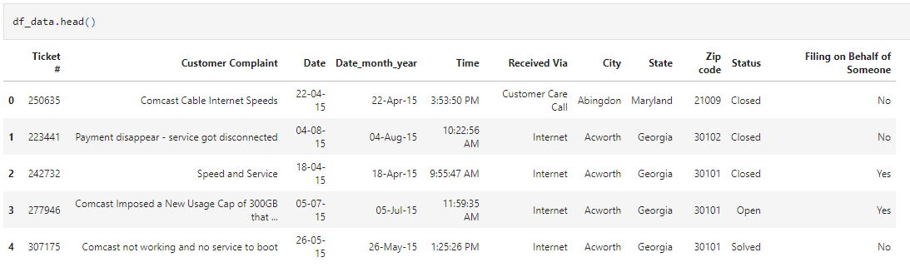

* df_data**.**tail()

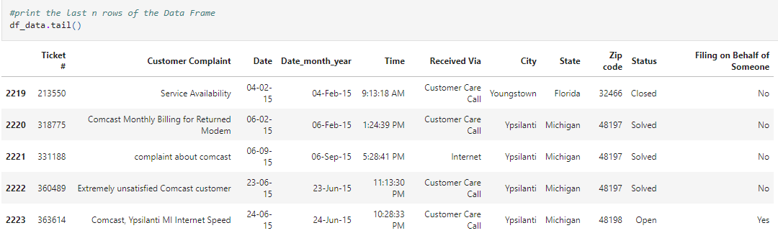

* df_data**.**info()

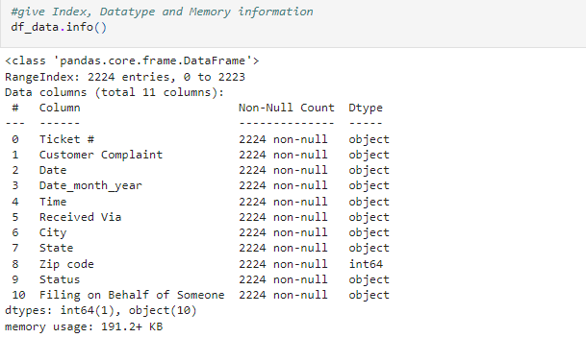

* df_data**.**isnull()**.**sum()

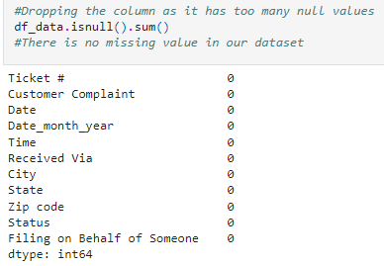

* df_data**.**fillna(df_data**.**median())

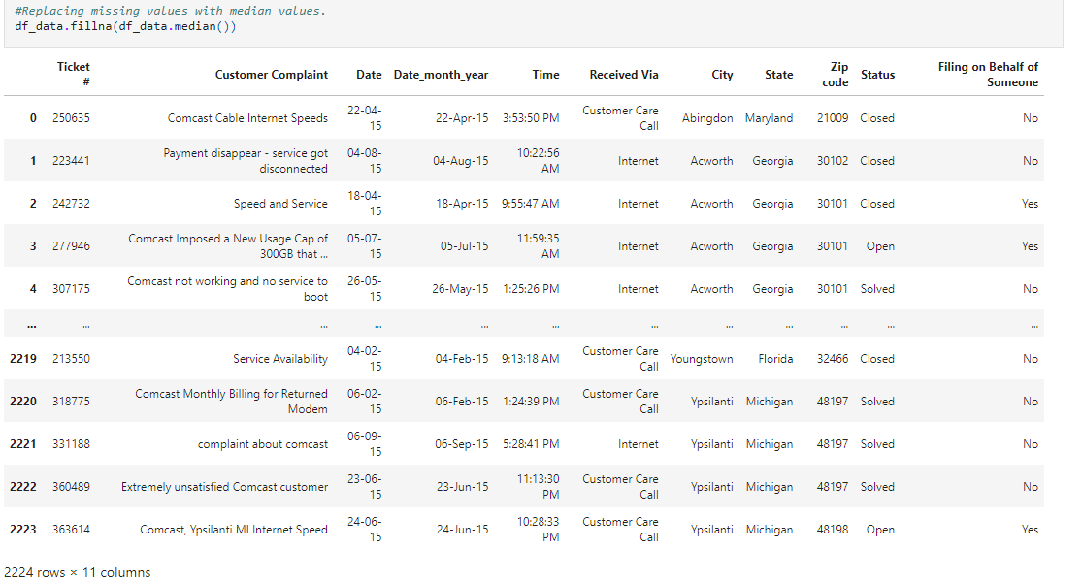

* df_data**.**fillna(df_data**.**median())

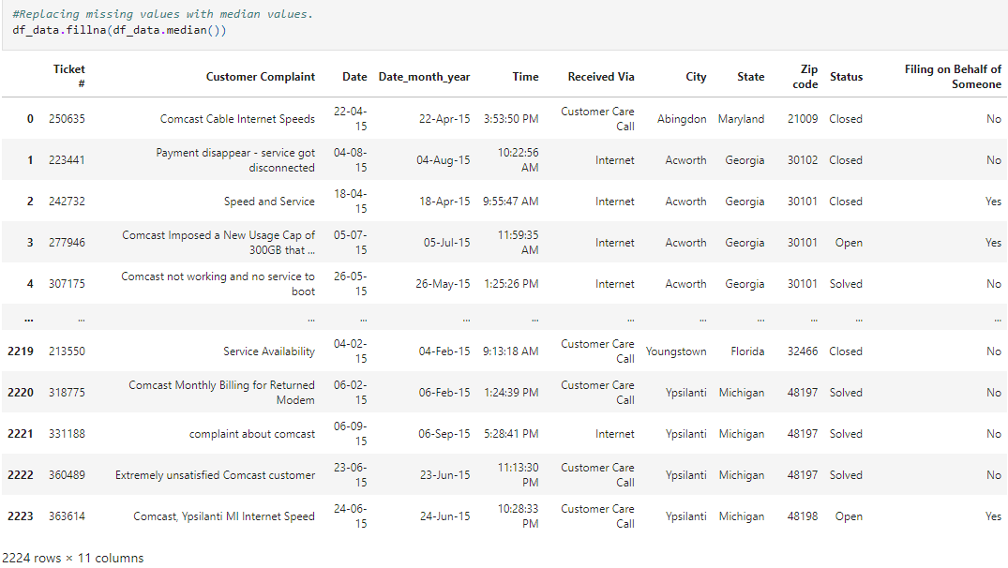

* df_data**=**df_data**.**mask(df_data**==**0)**.**fillna(df_data**.**mean())

df_data

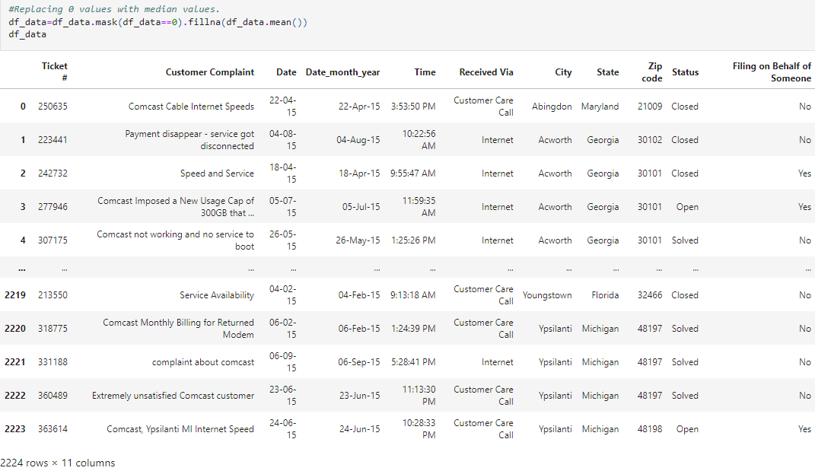

* df_data['Customer Complaint']**.**groupby(df_data**.**Date)**.**count()**.**plot(kind**=**'bar',figsize**=**(22,6))

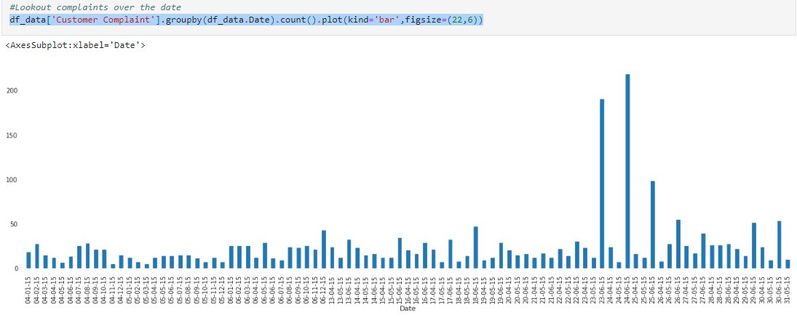

* **from** datetime **import** datetime **as** dt

df_data['month'] **=** pd**.**DatetimeIndex(df_data['Date'])**.**month

df_data['month']**=**df_data['month']**.**replace([1,2,3,4,5,6,7,8,9,10,11,12],['Jan','Feb','March','April','May','June','July','Aug','Sep','Oct','Nov','Dec'])

df_data['month']**.**value_counts()**.**plot(kind**=**'bar',color**=**'grey')

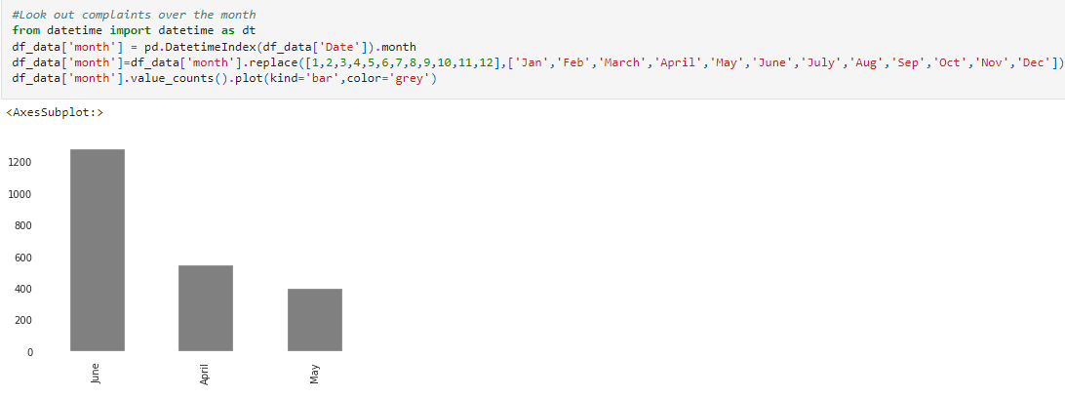

* sns**.**countplot(x**=**'month', hue**=**'Status', data**=**df_data)

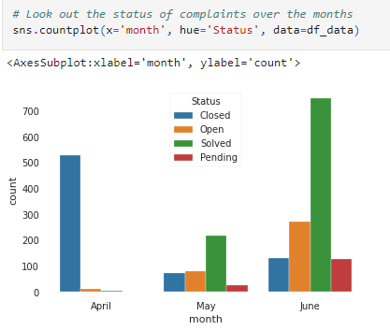

* df_state**=**df_data[['Ticket #', 'State']]**.**groupby('State')**.**count()**.**sort_values(by**=**'Ticket #',ascending**=False**)

df_state**.**describe

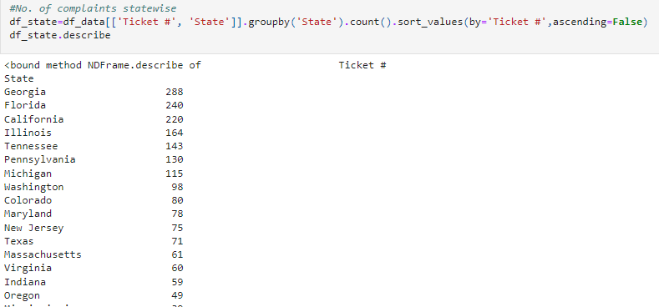

* df_state**.**plot(kind**=**'bar')

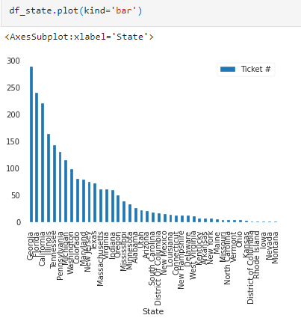

* **from** collections **import** Counter

c_count **=** Counter(df_data['Customer Complaint'])

x**=**c_count**.**most_common(10)

x**=**pd**.**DataFrame(d,columns**=**['type','count'])

x

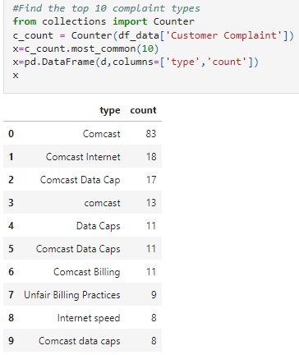

* x**.**plot(x**=**'type',kind**=**'bar')

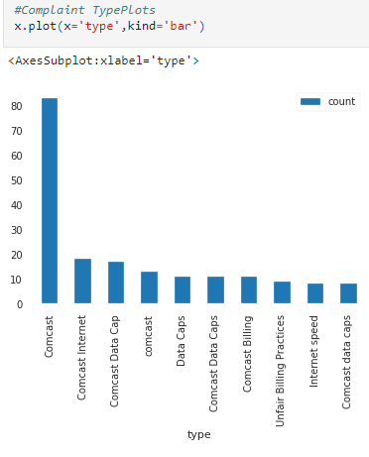

* State_solv_rate**.**plot(kind**=**'bar',stacked**=True**,figsize**=**(15,4))

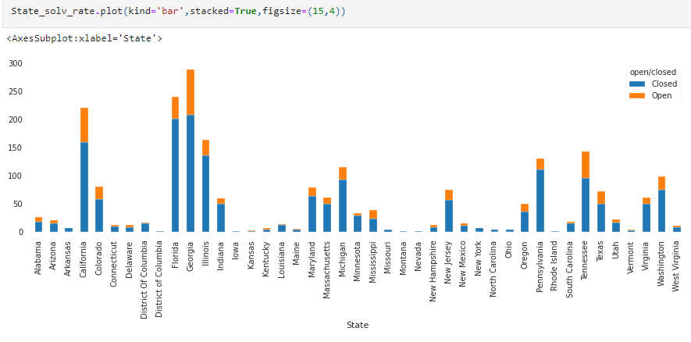

* *#% of complaints resolved till date*

